Care Bot

Graduation Project, Part-I (CS)
Computer Science Department
FCI, LUXOR

Project Advisors:
Dr. Mohamed Abdelhameid
Dr. Safynaze

Submitted by
Soliman Ali Soliman
Youssof Harby Okeil
Rabee Adel Beabesh
Mohamed Ahmed Mohamed
Abdelrahman Mahmoud Mohamed

Date submitted

Keywords
Keyword | Meaning
NLP | Natural language processing (NLP) is a field of artificial intelligence in which computers analyze, understand, and derive meaning from human language in a smart and useful way.
POS | Part-of-speech (POS) is a process of converting a sentence to forms – list of words, list of tuples (where each tuple is having a form (word, tag)).
SVM | Support vector machines (SVMs) are powerful yet flexible supervised machine learning algorithms which are used both for classification and regression. But generally, they are used in classification problems. In 1960s, SVMs were first introduced but later they got refined in 1990.
SMS | SMS (short message service) is a text messaging service component of most telephone, Internet, and mobile device systems. It uses standardized communication protocols that let mobile devices exchange short text messages. An intermediary service can facilitate a text-to-voice conversion to be sent to landlines
ICD | The International Classification of Diseases (ICD) is a globally used diagnostic tool for epidemiology, health management and clinical purposes.  The ICD is maintained by the World Health Organization (WHO), which is the directing and coordinating authority for health within the United Nations System.  The ICD is originally designed as a health care classification system, providing a system of diagnostic codes for classifying diseases, including nuanced classifications of a wide variety of signs, symptoms, abnormal findings, complaints, social circumstances, and external causes of injury or disease
MedDRA | The Medical Dictionary for Regulatory Activities (MedDRA) (link is external) is an internationally used set of terms relating to medical conditions, medicines and medical devices.  It was created to assist regulators with sharing information. It is also used by industry, academics, health professionals and other organizations that communicate medical information.
WordNet | WordNet is a lexical database of semantic relations between words in more than 200 languages.  WordNet links words into semantic relations including synonyms, hyponyms, and meronyms.  The synonyms are grouped into sunsets with short definitions and usage examples.
FL | Fuzzy Logic (FL) is a method of reasoning that resembles human reasoning. The approach of FL imitates the way of decision making in humans that involves all intermediate possibilities between digital values YES and NO.

ABSTRACT

The use of natural language processing (NLP) methods and their application to developing conversational systems for health diagnosis increases patients’ access to medical knowledge the proposed system is an artificial intelligent that aids the doctor in diagnosing diseases through listening to conversation between doctor and patient in order to specify the accurate diagnose and estimate the proper treatment with the help of the medical history of the patient to avoid any conflict in medication that may cause harm.
Table of Contents

1. Introduction 1
2. Domain Analysis 1
3. Risk/Constraints 2
4. Project Plan 3
5. Quality Assurance Plan 3
6. Requirements 4
6.1 Functional Requirements 4
6.2 Non-Functional Requirements 4
7. System Use-Cases 4
7.1 Use Case1 5
7.2 Use Case2 5
8. Analysis Class 5
9. Interaction Diagram 6
10. Design Class 8
11. System Architecture 8
12. User Interface Mockup 8
13. Database Schema 8
14. Algorithms 8
15. Expected Deployment 8
16. Sample Test Scenario 9
17. Project Status 9
18. Conclusion 9
19. Reference 9

List of Figures

Figure 1. Smart room use cases 4
Figure 2. Successful order placement 6
Figure 3. Successful order placement 7
Figure 4. Successful face recognition log in 7
Figure 5. System deployment diagram 9

List of Tables

Table 2. Test Table 9

Introduction
Remote diagnosis systems are becoming increasingly popular and accurate, with enormous advantages such as cost-effectiveness, fast and reliable decision support for medical diagnostics and treatment and prevention of disease, illness, injury, and other physical and mental damages in human beings. The rise in remote health services (or telehealth) offered by healthcare institutions coincided with the evolution of assisted living systems and environments, aiming to widen the possibility for older and disadvantaged people to access appropriate healthcare services and thus improve their health status and clinical outcome. With the increase in the innovation of medical technologies, there is a need to adopt medical expert systems that will oversee and control diagnosis and treatment processes Medical diagnostic processes carried out with the aid of computer-related technology which is on the rise daily have improved the experience and capabilities of physicians to make an effective diagnosis of diseases while employing novel signal processing techniques for analysis of patients’ physiological data and deep neural networks for decision support. With the rise of the artificial intelligence (AI) techniques, the intelligent doctor-assistant have appeared as a promising direction to emphasize the accuracy of diagnosing diseases & do deep analysis on the health records and symptoms of the patient to provide reliable health state of patients
The natural language processing (NLP) & technology can serve as an interaction between computers and humans using linguistic analysis and deep learning methods to obtain knowledge from an unstructured free text. The NLP systems have shown their uniqueness and importance in the areas of information retrieval mostly in the retrieval and processing of large amount of unstructured clinical records and return structured information by user-defined queries. In general, the NLP system is aimed at representing explicitly the knowledge that is expressed by the text written in a natural language. There are few applications of the NLP techniques in diagnosing diseases despite the enormous amount of text-based information, which can be retrieved from patients’ self-narrations The main challenges addressed by the application of NLP for medical records are flexible formatting, structure without sentences, missing expected words and punctuation, unusual parts of speech (POS), medical jargon, and misspellings Linguistic structures such as co-references make medical texts difficult to be interpreted Moreover, unique linguistic entities such as medical abbreviations make the inference of knowledge from medical texts much harder.
Applying Machine learning algorithms, especially SVM, have shown promising results in classifying free text & make a decision to assist medical experts in their diagnosis would serve as a boost in successfully improving healthcare services through effective analysis of narrative text of symptoms provided by a patient.
The proposed system serve as a doctor-assistant during the conversation with the patient by combining the NLP and machine learning algorithms to aid the doctor in the diagnosing and treatment process.

Related work
The ultimate goal of the Diagnostics Project is to put medical diagnostics in the hands of millions of underprivileged people without reaching a doctor, which is made possible thanks to the proliferation of portable smart devices including wearable devices that can instantly connect to the enormous computing power in the cloud. The project aligns with seeing the web as the ubiquitous computer. A Guide to the Concept of Embedded Ideas has also been published, using Semantic Web Concepts for a Restaurant Find app previously. This project expands these ideas and uses machine learning / text mining techniques to solve a critical problem affecting a large segment of the population - those related to medical diagnosis and broadening that insight to include health monitoring. The paper will present some preliminary findings in this direction and conclude with future directions.
Innovative medical technologies are developing day by day, as there is an important need for integrated medical expert systems (ESs) that will help to effectively manage and control diagnosis and treatment processes. These systems, with new approaches, have improved the experiences and capabilities of physicians to make the diagnosis of diseases. In this work, an integrated medical ES called Expert Doctor Verdis (Ex-Dr Verdis) is developed, which combines an advanced medical information system containing various medical services supported by information technologies, with ES capabilities in a single system. This system is also one kind of decision support system. Implementation of this system is applied for vertebral column diseases. Ex-Dr Verdis is a strong decision support tool with 94% sensitivity, 71% specificity, 87% positive, and 86% negative predictive values for the diagnosis of vertebral diseases. In addition to its facilities of medical information, Ex-Dr Verdis, with a sharing platform, provides physicians with the opportunity to share and discuss their own patients, cases, experiences, and expert knowledge with other colleagues. This integrated medical ES can be used in all hospital services, such as hematology, neurology, or cardiology, by adding new expert modules for other diseases.
Information Extraction (IE) refers to the automatic extraction of concepts, entities and events as well as their relations and associated attributes from free text. A recent review of clinical IE applications notes the increasing interest to NLP but lists only 25 IE systemswhich were used multiple times, outside the labs where they were created. Isolated attempts exist to apply IE in the context of EHR processing in frameworks for semantic search, for instance SemEHR deployed to identify contextualized mentions of biomedical concepts withinEHRs in a number of UK hospitals .We mention the following research prototypes as experimental developments, based on some sort of IE: reports about a system extracting textual medical knowledge from heterogeneous sources in order to integrate it into knowledge graphs; describes a machine learning system that annotates radiology reports and extracts concepts according to a model covering most clinically significant contents in radiology; presents the information extraction and retrieval architecture CogStack, deployed in the King’s College Hospital. CogStack has functionality to transform records into de-identified text documents and applies generic clinical IE pipelines to derive additional structured data from free texts. Most of the successful systems listed above work for clinical narratives in English. All major resources, ontologies and terminology classifications like UMLS4 and MESH5 are available in English. The comprehensive ontology SNOMED CT6 was developed initially in English and then translated to other languages.

Background
Hospitals are the most widely used means by which a sick person gets medical check-ups, disease diagnosis and treatment recommendation. This has been a practice by almost all the people over the world. People consider it as the most reliable means to check their health status. The proposed system is to create an alternative to this conventional method of visiting a hospital and making an appointment with a doctor to get diagnosis. This research intends to apply the concepts of natural language processing and machine learning to create a chatbot application.
People can interact with the chatbot just like they do with another human and through a series of queries, chatbot will identify the symptoms of the user and thereby, predicts the disease and recommends treatment. This system can be of great use to people in conducting daily check-ups, makes people aware of their health status and encourages people to make proper measures to remain healthy. According to this research, such a system is not widely used and people are less aware of it.
Executing this proposed framework can help people avoid the time-consuming method of visiting hospitals by using this free of cost application, wherever they are.
Human-computer speech is gaining traction as a method of computer interaction. There has been a recent rise in speech-based search engines and assistants like Siri, Google Chrome, and Cortana.
Natural language processing (NLP) techniques such as NLTK for Python can be applied to speech analysis, and intelligent responses can be found by designing an engine to deliver appropriate human responses. This type of program is called Chatbot. In this project we will deal with Natural Language Processing (NLP) techniques by sending a voice record that is converted into a text record, then analyzing speech and extracting symptoms, then disease diagnosis and treatment recommendation

Domain Analysis
[This is a sample from other resources. Ideally here you analyze the domain of your proposed work area. You can review existing approaches here and summarize your thoughts]

Home automation is a high potential market that is still under heavy development. There is no shortage of proprietary solutions and conceptual designs from companies of various sizes.

One existing solution for home automation that is already available on the market is the LonWorks Control Network from Echelon Corp. Similar to a Local Area Network (LAN), a LonWorks Control Network has a group of devices working together to “sense, monitor, communicate and control” In addition, the LonMark Interoperability Association exists to provide tools and components for manufacturers to integrate their devices into a LonWorks Network and currently has over 300 manufacturers on board. From their website:

Intelligent LONMARK products coupled with the Internet offer a whole new class of services to the home owner including; better control of energy usage, remote monitoring and control of devices in the home such as appliances, security, lighting, and sunblinds.

This solution has many strengths, including a “Visio Standard drawing and diagramming tool” for configuration of LonMark devices, automatic installation of newly attached devices, and the ability to network all devices through existing power circuits. However, the device standard is outdated and does not offer any wireless solution nor access to online XML data (Internet interaction is limited to remotely controlling devices). In addition, Echelon Corp. is targeted towards the enterprise market – integration support for home appliances is very limited. The LonMark Starter Kit retails for US$1,999.95

Hitachi has recently announced a solution that integrates a touch screen computer into a mirror. The device is called “Miragraphy” and it can display digital information (text, photos, video, websites, etc.) on a mirror surface using an LCD projector. barcode readers and cameras that are used to personalize digital content based on the identities of the user. The product is currently only available in Japan. It is targeted at public locations (restaurants, hotels, airports, etc.) instead of consumer homes. No information was available on the pricing. Unfortunately, this solution is hardwired and does not have a well-defined home automation protocol that can be extended to other devices.
In January 2006, Bill Gates showcased a system at the 2006 Consumer Electronics Show that used a large touch screen to display the time, a calendar, family photos, a map with GPS locations of family members, and even a live TV feed. "Consumers are getting more and more connected. They're getting richer experiences, and software is really at the center of that.", explained Gates He stated the product would be a reality for consumer living rooms within the next four years. While the product does not compete directly with the home automation solution we are developing, it does confirm the future demand for online data in home displays and the need for a well-built infrastructure to facilitate the control of a network of such devices.

Techniques
One of the difficulties faces doctors when meet patients they didn’t have knowledge about his medical history like Previous diseases, treatments and symptoms for this patient.
Accordingly, we thought about storing this medical data for everyone to give ability to doctors to right diagnose disease or specify the right medicine according to his medical history
So, we provide a AI Model based on NLP and ML techniques to hears conversation between doctor and patient to extract symptoms to diagnose disease finally decision for doctor
- NLP model: to convert audio to text and do preprocessing extract symptoms exchange it to vector of feature
- ML model: take vector of symptoms and classify this to diagnose and get this specific disease
We will implement this as a back-end and host it on serve and provide APIs to can use it on android or desktop or our site.
So… in android:
Application components:
    - Login page: This page has the user name and password, and it also has a button for the registration page if the user is not registered.
Registration page: A page that enables the user to register, to be able to use the application as a doctor or normal user.
After the user logs in:
- The Doctor will see a page containing:
  - Diagnose page: this contains the options to scan QR code for patient to see his medical history, Start and stop recording between doctor and patient to upload recorded audio to diagnose and option to add new medical record and note for this patient.
- The Normal user will see a page containing:
  - Diagnose page: this contains the options to see his medical history and add new medical record and note for his medical history.

Risk/Constraints
- Risks
Risk | Effect
- Patient may not know how to use application  - Patient may speak unclearly  - Patient may describe the disease in the wrong way  - Patient may enter incorrect data | Which may lead to incorrect diagnosis
User does not have internet | Which leads to the program not working
Patient speaks in an unsupported language | Which leads to the failure of the program
Patient describes an untrained disease for the program | Program can’t detect the disease
- Constraints
  - User should have the application on his device
  - User must have internet on his device and always run when using application
  - User should speak in a clear voice
  - User should talk about symptoms in a clear and direct way
  - User should know how to deal with the application

Project Plan

Activity | Proceeding activity | Duration
Converting voice of conversation to text  (A) | None
Proposing Natural Language Processing mode to  Make text preprocessing  (B) | None
Testing Natural Language Processing mode to  Make text preprocessing  (C) | B
Extracting Symptoms from Text with NLP Model  (D) | A, B, C
proposing machine learning model classification illness  (E) | None
Testing machine learning model classification illness  (F) | E
proposing machine learning model to prediction Appropriate treatment  (G) | None
Testing machine learning model to prediction Appropriate Treatment  (H) | G
BACK END AND HOSTING  (I) | A, B, C, D, E, F, G, H
proposing android app for doctor  (J) | A, B, C, D, E, F, G, H, I
Connect doctor app with HOSTING  (K) | A, B, C, D, E, F, G, H, I, J
proposing android app for patient for record Previous illnesses  (L) | None
Testing apps and make optimizations  (M) | A, B, C, D, E, F, G, H, I, J, K, L

Quality Assurance Plan

The planning phase is an important step for any project.

- Inspections: Should be done before formal reviews and should be used at the end of each major phase/iteration. Participants in an inspection are members of the team (without the adviser). Part of the work done by 1 student is reviewed by 1, 2 or all the members of the team. There must be a written report of the findings and follow up on the inclusion/correction of all findings. A template can be used to record findings from an inspections session.

In summary: this is like when the students divide their work among the team members and once they finish their assigned task, they check each other’s work and give feedback to the person initially responsible for that part.

A sample written inspection report can be put in appendix in the project report as a proof that students conducted inspection sessions.

- Formal Reviews: Should follow an inspection and should be used at the end of each major phase and/or iteration (Requirements specs, design, test plan, etc.). Formal reviews should be conducted in a formal way with the presence of students and the adviser (and eventually the exam committee). There must be a written report documenting all findings from the formal review session. The adviser is responsible to follow up with students. The report must be filled by the advisor and eventually the member of the exam committee.

The written report can be put in appendix in the project report as a proof that students conducted formal review sessions with their adviser and eventually the exam committee members.

- Testing: For this, there is a section before the end of this report where the students’ should put their test-related content. At this part of the project, the students can prepare a rough test plan and include that in their report. The test plan should include various test cases.

Requirements

Functional Requirements
    - A fully function mobile app that controls work-flow with servers, APIs, doctors & patients in an organized, accurate and quick methods.
    - The System must store all required data about doctors (ids, info, and assigned patients), patients (ids, info, medical history, medical reports, and treatments).
    - A Speech Recognition System to record conversation between doctor & patient.
    - A Server that store data & Machine Learning Models.
    - API to guarantee communication between server & application.
    - A fully functional & tested Machine Learning Model that do analysis on texts to extract symptoms and diagnose diseases.
    - A system to specify proper treatments based on diagnose.
    - A user interface that enables patients & doctors to create accounts, add medical records, check their medical history.
    - The doctor must be able to record conversations with the patient and send it directly to the machine learning model for analysis through API.
    - The doctor must be able to receive the generated report with the full diagnose report & treatment and confirm it.

Non-Functional Requirements
- Fast APIs & data retrieval from servers within seconds.
- Quick Analysis & Classifying Texts using efficient algorithms.
- A clear , attractive , responsive , less-leggy & efficient User-interface that guarantee good user experience and handle variety of tasks.
- High security to prevent unauthorized accesses and guarantee the safety & integrity of data.
- A well-organized and manageable system architecture that ease the process of maintenance, recoverability & scalability.

System Request
Machine learning in medical diagnosis has helped several healthcare organizations to improve the patient's health and reduce healthcare costs, using superior diagnostic tools and effective treatment plans. It is now used in healthcare to make almost perfect diagnosis, predict readmissions, recommend medicines, and identify high-risk patients. These predictions and insights are drawn using patient records and data sets along with the symptoms exhibited by the patient so the proposed system eases the process of diagnose for the doctor and patient through automation of the diagnose process to reduce the chance of in-proper diagnose or treatments also there`s no longer need for a physical place or any travelling cost for the patient they can just do it online and the proposed system ensures the value of customer experience and customer-satisfaction.
Functionality:-
- The Ability to record and store conversations between doctor & patient.
- The ability to analyze those records & predict the disease and the proper treatment based on the medical history
- The ability to generate full reports about the status of the patient.
- The ability to store medical histories for the patients as a reference for them.
Expected Value:-
- Less-cost examinations process.
- More-fast diagnosis process.
- More organized reports and records.
- Less paper-work stuff.
- More accurate and reliable diagnosis.
- Ease-to-use application and friendly User-interfaces.
- Increase productivity.
- Customer-satisfaction.
Special Constraints:-
The ability of doctors & patients to deal with Technology.
The short development life-time.

System Use-Cases
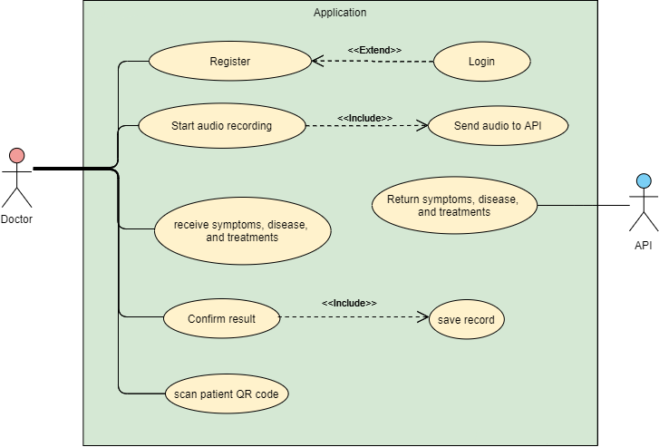
Figure 1. Use case
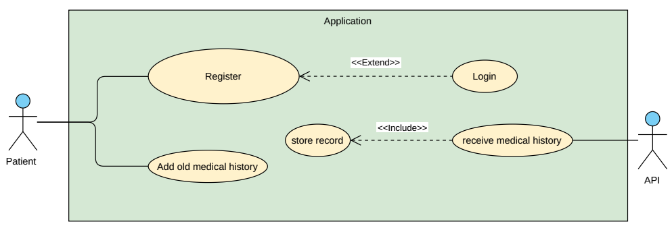
Figure 2. Use case
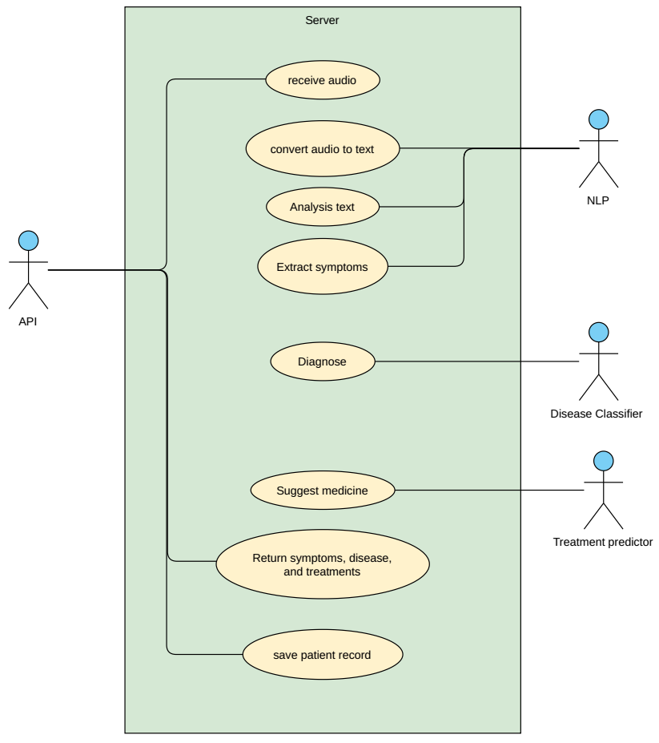
Figure 3. Server use case
Register: To use app must have account to create account as Doctor and doctor must enter all required information
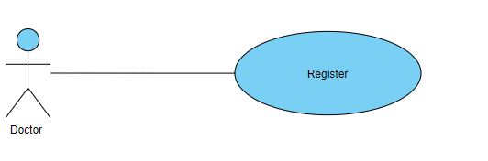
Login: To log in the app the user must enter username and password
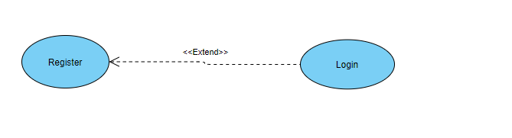
Start Audio Recording: Doctor starts audio record to voice recording conversation between him and patient

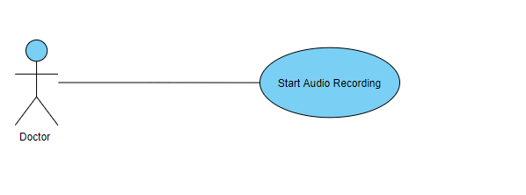
Send Audio To API: After conversation voice recording it will send to model to start classification
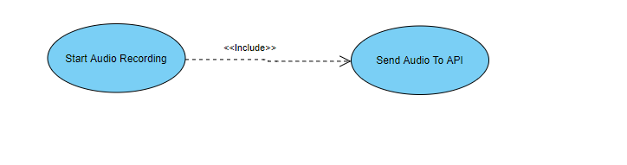
Receive Audio: server received the conversation
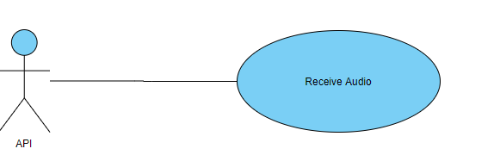
Convert Audio to Text: NLP start preprocessing text by convert Audio TO Text
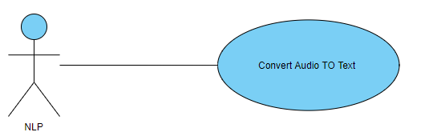
Analysis Text: NLP receive text after converting and start analysis text
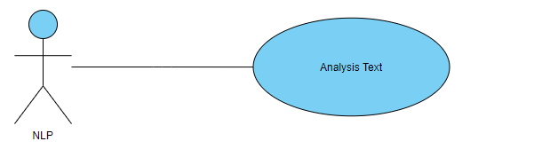
Extract Symptoms: NLP will Determines Symptoms after make Analysis to Text
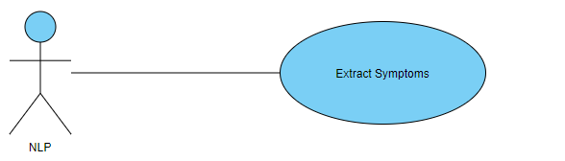
Diagnose: after Extract Symptoms Disease Classifier will receive Symptoms and predict diseases
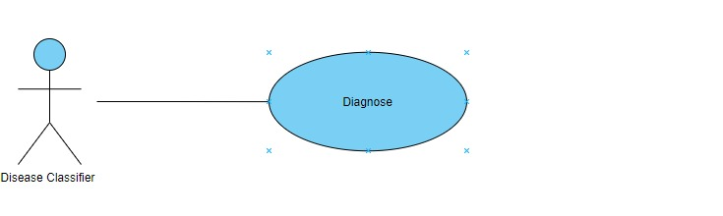
Suggest Medicine: after predict Diseases Treatments predictor will receive Diseases and Suggest Medicine
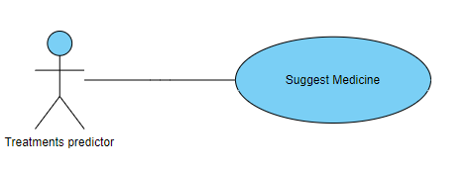
Return Symptoms, Disease, Treatments: after make classification Symptoms and Disease and predict with Treatments API will return what are Symptoms and Diseases and Treatments
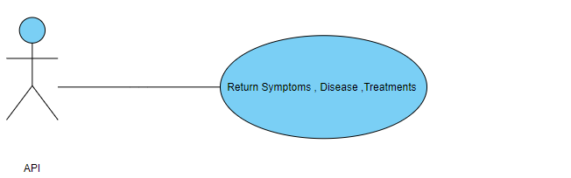
Receive Symptoms, Disease, and Treatments: doctor Receive Symptoms and Diseases and Treatments that can use to make decision for patient Illness
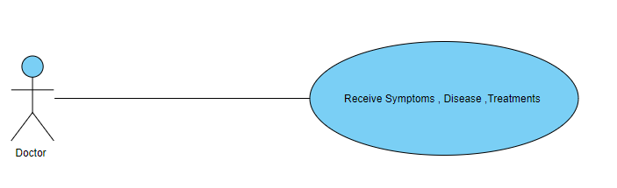
Scan Patient QR Code: Doctor Scan Patient QR Code to be able view patient medical history
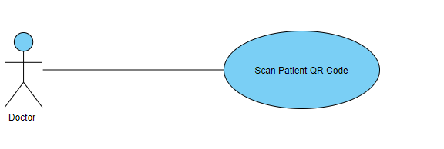
Confirm result: Doctor add record to patient medical history
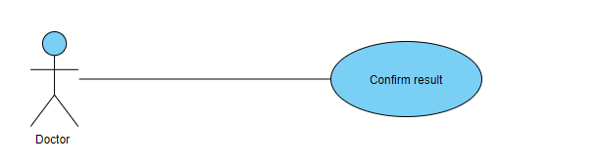
Save Record: send Record to API

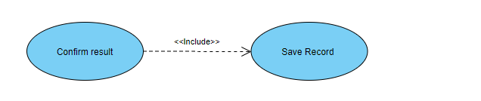
Register: To use app must have account to create account as Patient and Patient must enter all required information
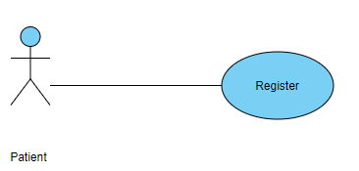
Add Medical History: patient add all old medical records
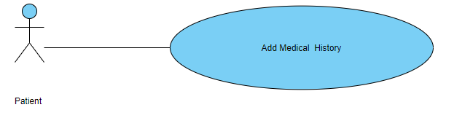
Receive Medical History: after add medical history API Receive Medical History and sent to server
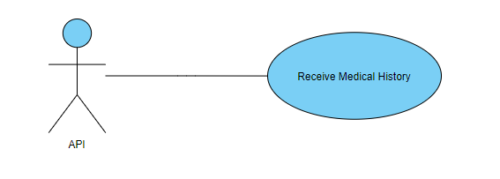
Store Record: Server receive medical records and stored 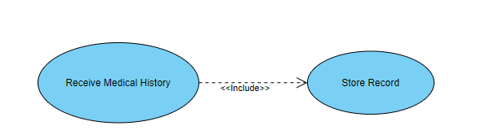

Use Case Description (Use case scenario)

Use case name | Register | Unique ID | CAREBOT-User-001
Area | Care Bot
Actor(s) | User (Patient, or Doctor)
Level | Blue
Description | User creates account
Triggering Event | User click “Register” button in the application
Preconditions | - The user needs to download application then open it  - The user needs to have internet access
Postconditions | - User has successfully create account
Assumptions | - User have Care bot application  - A valid data
Steps Performed |  | Information for Steps
- Open application  - Choose if he is a patient or doctor  - User enters his data  - Click on “Create Account” button  - Validation of entered data by application |  | Step 3: Name, UserName, Password, E-mail, SSN, EMSN (Egyptian Medical Syndicate Number if he was a doctor)
Extensions (Alternative Flows) | - If the downloading interrupted for any reason, use should try again and download it  - If user entered a non-valid data, a warning message should appear to him

Use case name | Login | Unique ID | CAREBOT-User-002
Area | Care Bot
Actor(s) | User(Patient, or Doctor)
Level | Blue
Description | User login to his account
Triggering Event | User click “Login” button in the application
Preconditions | - The user needs to download application then open it  - The user needs to have internet access  - The user needs to have account
Postconditions | - User has successfully logged in to his account
Assumptions | - User have Care bot application  - A valid data
Steps Performed |  | Information for Steps
- Open application  - User enters his data  - Click on “Login” button  - Validation of entered data by application |  | Step 2: E-mail, Password
Extensions (Alternative Flows) | - If user entered a non-valid data, a warning message should appear to him

Use case name | Adding old medical history | Unique ID | CAREBOT-Patient-001
Area | Care Bot
Actor(s) | Patient
Level | Blue
Description | Patient adds old medical history
Triggering Event | Patient click “Add old medical history” button in the application
Preconditions | - The Patient needs to login in to his account
Postconditions | - Patient has successfully added old medical history to his account
Assumptions | - Patient have Care bot application  - A valid data
Steps Performed |  | Information for Steps
- Open application  - Patient log in  - Patient click “Add old medical history” button  - Patient Enters his data  - Patient clicks on “Save” button  - Validation of entered data by application |  | Step 2: E-mail, Password  Step 4: Symptoms, Disease, Treatment
Extensions (Alternative Flows) | - If user entered a non-valid data, a warning message should appear to him

Use case name | Start audio recording | Unique ID | CAREBOT-Doctor-001
Area | Care Bot
Actor(s) | Doctor
Level | Blue
Description | Doctor start new diagnose
Triggering Event | Doctor click “Start audio recording” button in the application
Preconditions | - The Doctor needs to login in to his account
Postconditions | - Audio has successfully recorded, submitted to server and returned result
Assumptions | - Doctor have Care bot application  - Patient should speak in a clear voice  - Patient should talk about symptoms in a clear and direct way
Steps Performed |  | Information for Steps
- Open application  - Doctor log in  - Doctor click “Start audio recording” button  - Patient start talking and describes how he feels ‘symptoms’  - Doctor clicks on “Finish recording” button  - Validation of entered data by application and send data to server  - Server respond with result  - Doctor adds note if he want  - Doctor click “Save” button |  | Step 2: E-mail, Password  Step 4: Audio  Step 8: Note  Step 9: Symptoms, Disease, Treatment, Note
Extensions (Alternative Flows) | - If doctor entered a non-valid data in login, a warning message should appear to him

Use case name | Scan patient QR code | Unique ID | CAREBOT-Doctor-002
Area | Care Bot Application, Server
Actor(s) | Doctor
Level | Blue
Description | Get patient’s old medical history
Triggering Event | Doctor click “Scan QR” button in the application
Preconditions | - Doctor needs to login in to his account  - Patient needs to login in to his account  - Patient must have QR code
Postconditions | - Doctor has successfully get patient’s old medical history on his device
Assumptions | - Doctor have Care bot application  - Patient should have QR code  - Doctor phone have a camera
Steps Performed |  | Information for Steps
- Open application  - Doctor log in  - Doctor click “Scan QR” button  - Doctor scan QR code by his camera  - Validation of entered data by application and send data to server  - Server respond with result |  | Step 2: E-mail, Password  Step 4: QR code  Step 6: Old_Medical_History
Extensions (Alternative Flows) | - If doctor entered a non-valid data in login, a warning message should appear to him  - If patient have non-valid QR code, then patient must generate new QR code in his account

Use case name | Convert audio to text and extract symptoms | Unique ID | CAREBOT-NLP-001
Area | Server
Actor(s) | NLP
Level | Blue
Description | Convert audio received to text then extract symptoms
Triggering Event | API send audio
Preconditions | - There is no preconditions
Postconditions | - NLP module has successfully converted audio to text and extracted symptoms
Assumptions | - The audio have to be clear
Steps Performed |  | Information for Steps
- Convert audio to text  - Analyze text  - Extract symptoms from text  - Send symptoms |  | Step 1: Audio  Step 2: Text  Step 4:Symptoms
Extensions (Alternative Flows) | - If audio wasn’t clear, a warning message should appear to doctor to re-record audio  - If language wasn’t supported , a warning message should appear to doctor to re-record audio in supported language  - If patient described an untrained disease for program, a warning message should appear to doctor that program couldn’t extract symptoms  - If module couldn’t extract symptoms from text, a warning message should appear to doctor that program couldn’t extract symptoms

Use case name | Classification of the disease | Unique ID | CAREBOT-DiseaseClassifier-001
Area | Server
Actor(s) | Disease Classifier
Level | Blue
Description | Getting symptoms and predict disease
Triggering Event | NLP module sent symptoms to disease classifier
Preconditions | - There is no preconditions
Postconditions | - Disease classifier module has successfully predicted disease
Assumptions | - NLP module must send symptoms
Steps Performed |  | Information for Steps
- Disease classifier analyze symptoms and predict disease  - Return result |  | Step 1: Symptoms  Step 2: Disease
Extensions (Alternative Flows) | - If module couldn’t analyze symptoms to predicate disease, a warning message should appear to doctor that program couldn’t predict disease

Use case name | Suggest medicine | Unique ID | CAREBOT- TreatmentPredictor-001
Area | Server
Actor(s) | Treatment predictor
Level | Blue
Description | Suggest medicine
Triggering Event | Disease classifier sent predicted disease to treatment predictor
Preconditions | - Disease classifier sent predicted disease
Postconditions | - Treatment predictor provided appropriate treatment
Assumptions | - Disease classifier must sent predicted disease
Steps Performed |  | Information for Steps
- Treatment predictor analyze disease and search for the best medicine for it  - Return result |  | Step 1: Disease  Step 2: Medicines
Extensions (Alternative Flows) | - If module couldn’t analyze disease to predicate medicine, a warning message should appear to doctor that program couldn’t predict appropriate medicine

Analysis Class

Context Diagram
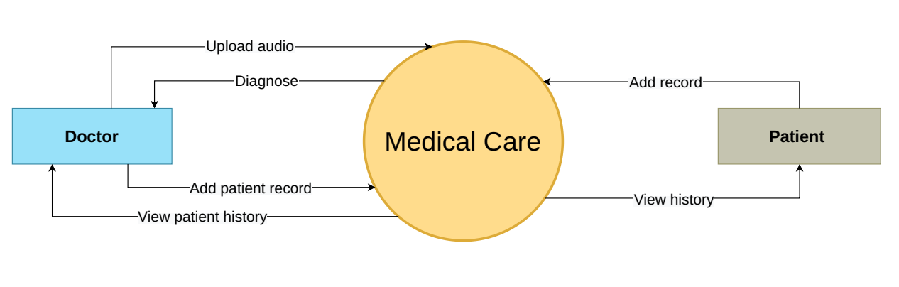
Figure 4. Context diagram

State Diagram

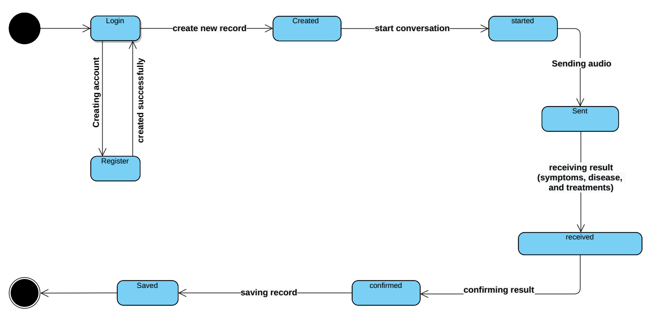
Figure 5. Doctor state diagram

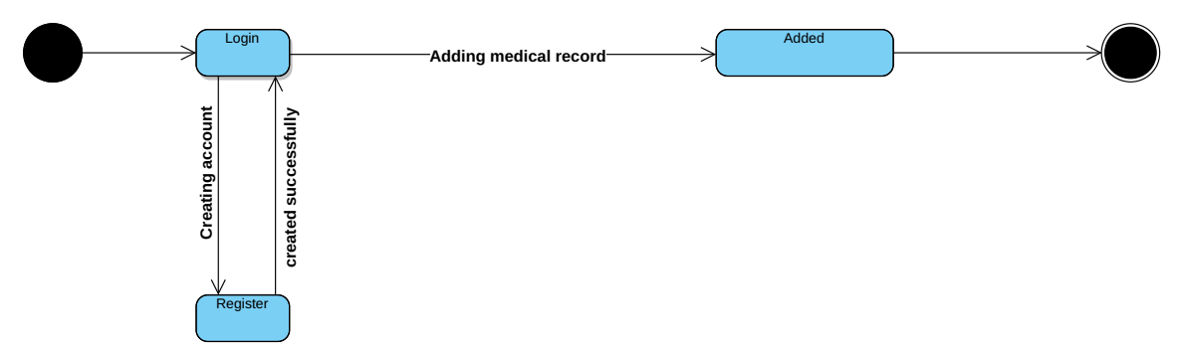
Figure 6. Patient state diagram

Interaction Diagram (Sequence Diagram)

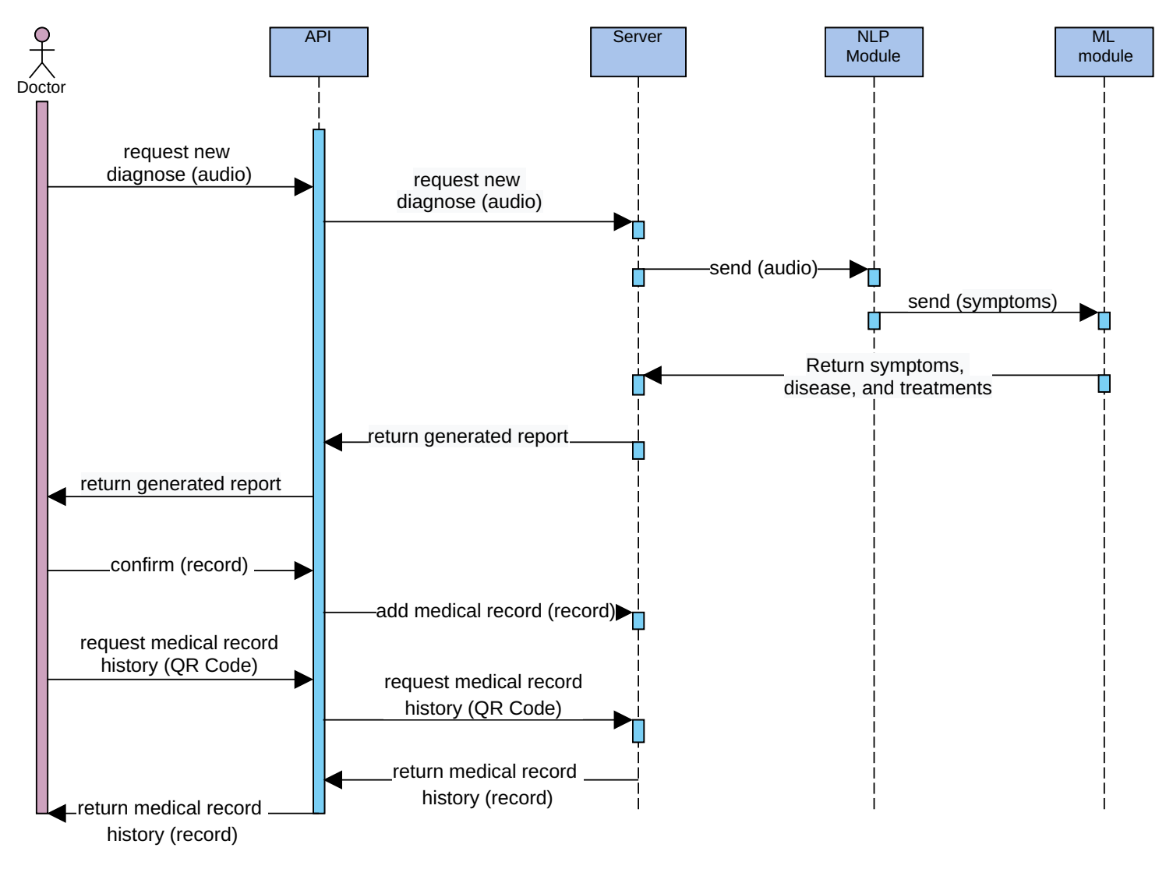Figure 7. Sequence diagram
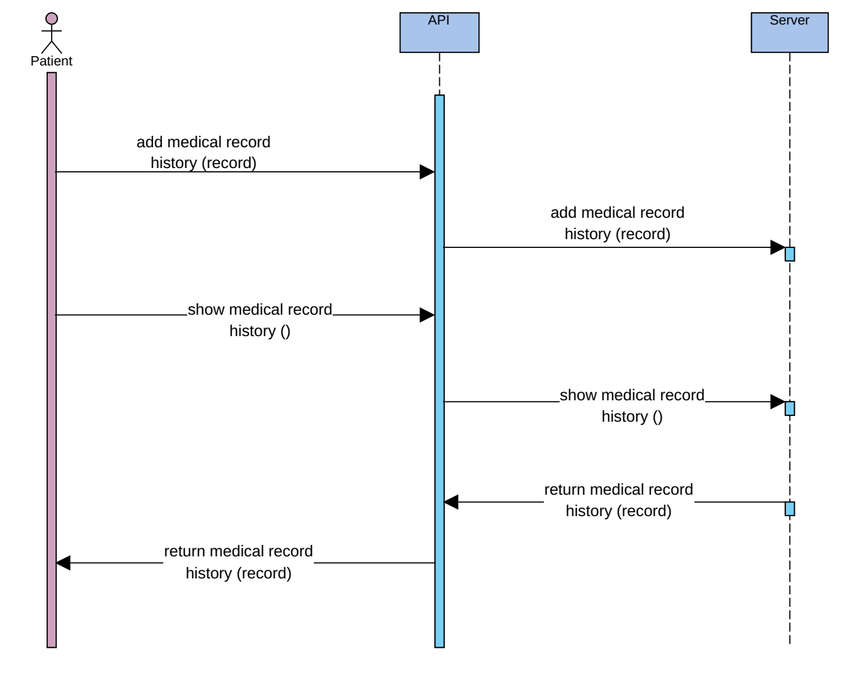
Figure 8. Sequence diagram

Design Class

12.1 Class Diagram
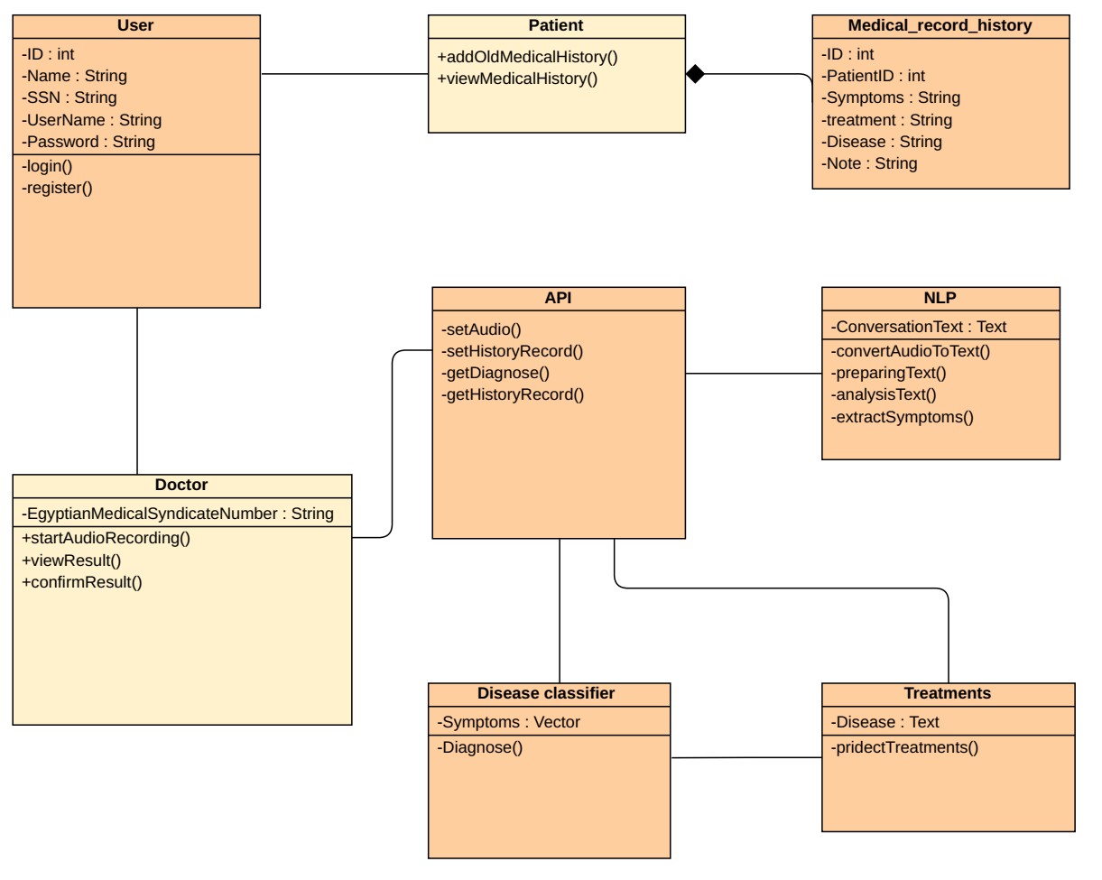

Figure 9. Class diagram

12.2 Class Diagram

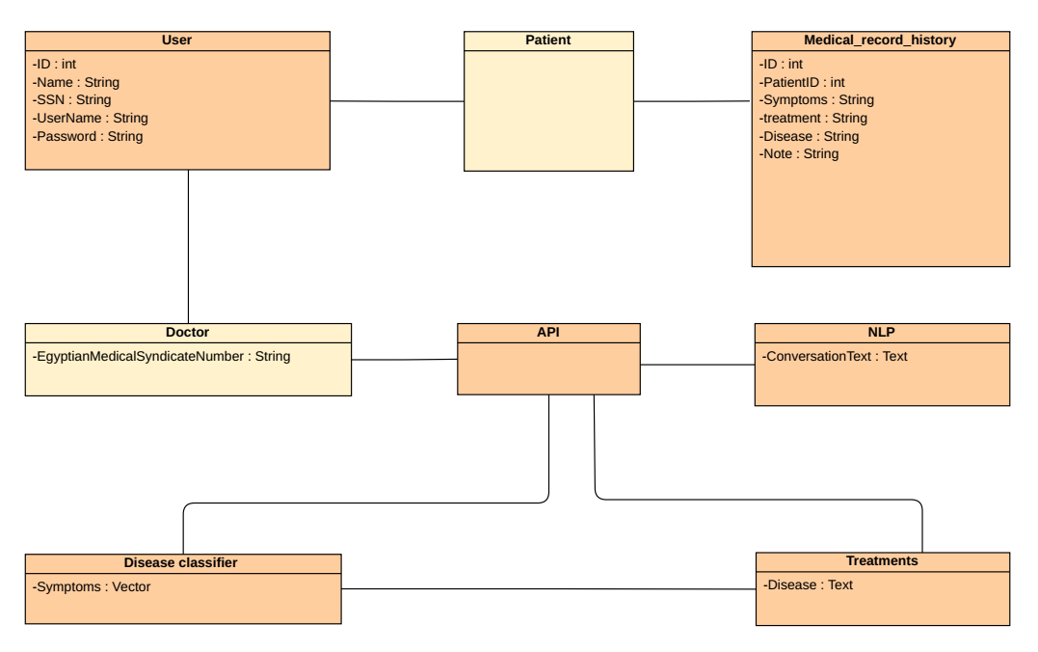
Figure 10. Domain diagram

System Architecture

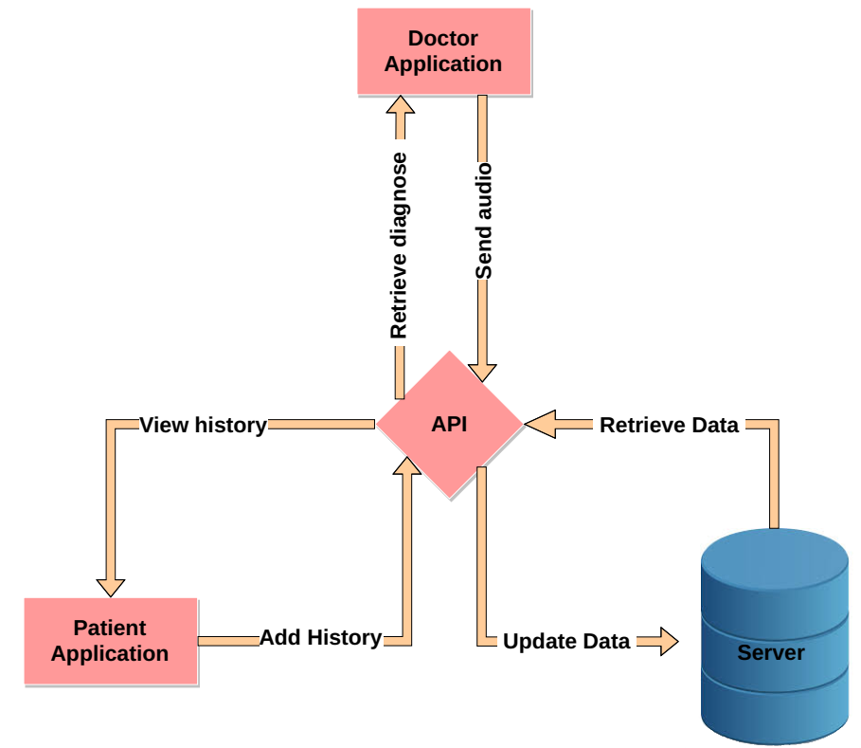
Figure 11. System architecture

User Interface Mockup

Provide screen shots of the developed user interfaces, or mockups to illustrate the looks and feel of the system for critical scenarios.

ER Diagram
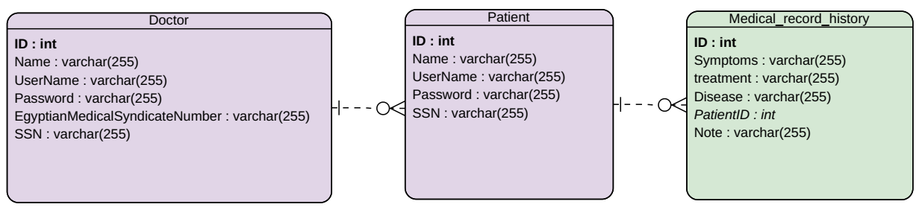
Figure 11. Entity relationship diagram

Database Schema
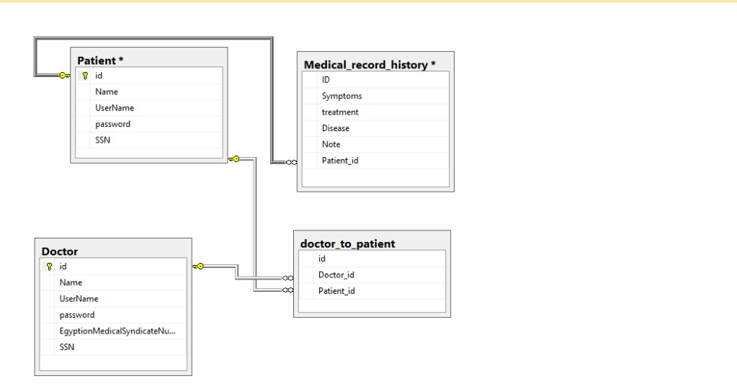
Figure 12. Database Schema

Algorithms
Give brief overview of any special algorithms you will use e.g. image processing, game strategy, scheduling etc.

Expected Deployment

Global Overview
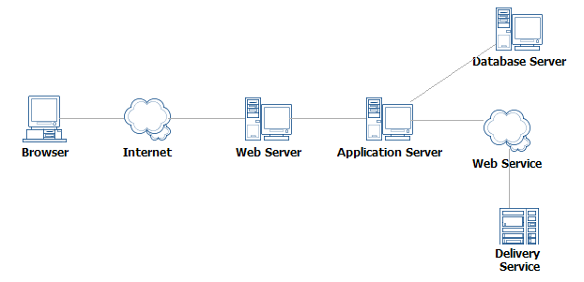
Figure 2. System deployment diagram

Test Scenario
You need to specify some important test cases for some scenarios by identifying sample input and expected output of the system’s core component/classes.

Table 1. Test Table
Col1 | Col2 | Col3

Methodology
Main Work:
We can divide our application’s main work into main four parts:
- Learning android developing basics.
  - Before developing our application, we needed to read about android because knowledge about android developing was not sufficient enough to start developing the project.
- Learning Machine learning techniques.
- Learning Natural Languages processing techniques.
- Apply text preprocessing on text after convert it from audio.
- Apply NLP techniques on text
- Apply machine learning on the data set.
Applications and languages used:
- Languages used:
- Java language.
- Python language.
- SQLite language.
- Applications used:
- Android Studio.
- Jupyter notebook.

Project Status
[Give the current status of the project following the status report template—mention the different issues you have worked on and the issues that you plan to work on in the subsequent iterations]

Conclusion
Write the conclusion here.

Reference
Write the references here that you used..

